# OSPF Dynamic Routing Protocol

**🎯 Objective:**

Configure and verify **OSPF (Open Shortest Path First)** routing on a three-router network to dynamically share routing information using **OSPF process ID 1**.

**🖧 Network Topology:**

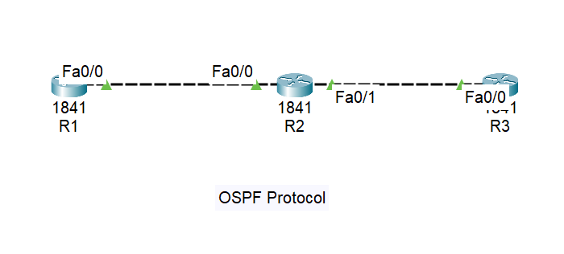

**📋 IP Addressing Table:**

| **Router** | **Interface** | **IP Address** | **Subnet Mask** | **Connected Network** |
| --- | --- | --- | --- | --- |
| R1 | Fa0/0 | 192.168.12.1 | 255.255.255.0 | 192.168.12.0/24 |
| R2 | Fa0/0 | 192.168.12.2 | 255.255.255.0 | 192.168.12.0/24 |
| R2 | Fa0/1 | 192.168.23.1 | 255.255.255.0 | 192.168.23.0/24 |
| R3 | Fa0/0 | 192.168.23.2 | 255.255.255.0 | 192.168.23.0/24 |

**🔧 Router Configuration**

**🔹 CLI on Router1 (R1):**

R1> enable

R1# configure terminal

R1(config)# interface Fa0/0

R1(config-if)# ip address 192.168.12.1 255.255.255.0

R1(config-if)# no shutdown

R1(config-if)# exit

R1(config)# router ospf 1

R1(config-router)# network 192.168.12.0 0.0.0.255 area 0

R1(config-router)# exit

R1(config)# exit

R1# write memory

**🔹 CLI on Router2 (R2):**

R2> enable

R2# configure terminal

R2(config)# interface Fa0/0

R2(config-if)# ip address 192.168.12.2 255.255.255.0

R2(config-if)# no shutdown

R2(config-if)# exit

R2(config)# interface Fa0/1

R2(config-if)# ip address 192.168.23.1 255.255.255.0

R2(config-if)# no shutdown

R2(config-if)# exit

R2(config)# router ospf 1

R2(config-router)# network 192.168.12.0 0.0.0.255 area 0

R2(config-router)# network 192.168.23.0 0.0.0.255 area 0

R2(config-router)# exit

R2(config)# exit

R2# write memory

**🔹 CLI on Router3 (R3):**

R3> enable

R3# configure terminal

R3(config)# interface Fa0/0

R3(config-if)# ip address 192.168.23.2 255.255.255.0

R3(config-if)# no shutdown

R3(config-if)# exit

R3(config)# router ospf 1

R3(config-router)# network 192.168.23.0 0.0.0.255 area 0

R3(config-router)# exit

R3(config)# exit

R3# write memory

**🔎 Verification Commands & Sample Output**

**✅ 1. Check OSPF Neighbors**

R2# show ip ospf neighbor

**Sample Output:**

Neighbor ID Pri State Address Interface

192.168.12.1 1 FULL/DR 192.168.12.1 FastEthernet0/0

192.168.23.2 1 FULL/DR 192.168.23.2 FastEthernet0/1

**✅ 2. Check OSPF Routes**

R1# show ip route ospf

**Sample Output:**

O 192.168.23.0/24 [110/2] via 192.168.12.2, 00:20:57, FastEthernet0/0

**✅ 3. Check OSPF Configuration**

R3# show ip protocols

**Sample Output:**

Routing Protocol is "ospf 1"

Outgoing update filter list for all interfaces is not set

Incoming update filter list for all interfaces is not set

Router ID 192.168.23.2

Number of areas in this router is 1. 1 normal 0 stub 0 nssa

Maximum path: 4

Routing for Networks:

192.168.23.0 0.0.0.255 area 0

Routing Information Sources:

Gateway Distance Last Update

192.168.12.1 110 00:24:43

192.168.23.1 110 00:21:14

192.168.23.2 110 00:21:14

Distance: (default is 110)

**🛠️ Troubleshooting Tips**

| **Problem** | **Possible Cause** | **Solution** |
| --- | --- | --- |
| No neighbor adjacency | Mismatched OSPF area ID | Make sure all routers are in **area 0** |
| No OSPF routes | Incorrect network statement | Use correct subnet & wildcard mask |
| Interface not up | Shutdown or cable issue | Use no shutdown on all interfaces |
| DR/BDR issues | Priority or mismatch | Adjust OSPF interface priority if needed |
| Inconsistent routing | Missing interfaces | Use show ip ospf interface to confirm OSPF is running on all interfaces |